Quality Plan

*RDC, ASCOM, PA – Document Management System*

**1. Introduction**

This document, together with other referenced documents, defines the responsibilities and procedures to be adopted to ensure that the data and information produced as part of Project RDC, ASCOM, PA – Document Management Systemare reliable, fit for purpose and consistent with documented objectives and deliverables. It serves as a reference for the developers the system and of the internal management that governs the decisions and instructions concerning project quality assurance.

**2. Project Contractual Information**

|  |  |
| --- | --- |
| Project: | RDC – Document Management System |
| Programme Co-ordinator: | Lt. Col Leo Edward Caranto |
| Principal Investigators(s): | RDC Quality Assurance Division  RDC Administrative Division |

**3. Scope of Work and Quality Objectives**

|  |  |
| --- | --- |
| Scope of work: | The coverage of the Project RDC – Document Management System is as follows:   * Only the processes within the office will be automated * A database for archiving or finalizing documents * Only the admin user can add, edit, or delete accounts * Only employees in the administrative division can create a new test-project   Access on the system is only available for the employees of the Research Development Centre. These employees should have an account that is entered by the administrative division. |
| Quality Objectives: | The quality objectives of the Project RDC - Document Management System are as follows:   * To automate processing of papers for the employees of RDC * To develop a database where access and archiving of files can be faster * To improve the client’s business process in terms of reducing usage of papers and improving speed of processing documents. |
| QA Requirement: |  |

**4. Project Organisation**

|  |  |
| --- | --- |
| Project Manager(s): | Caranto, Edric Jon Cleon B.  *Project Manager* |
| Task Manager(s): | *Name and position of Task Managers and nominated deputies* |
| Quality Assurance: | Caranto, Edric Jon Cleon B.  *Project Manager* |
|  |  |
| Other Team Members: | Buan, Michael John S.  *Project Developer*  Carlos, Christian Aleck S.  *Project Developer* |
| Technical Reviews: | Lt. Col. Leo Edward Caranto  *Project Sponsor*  Catayoc, Jacob  *Project Adviser*  Sanchez, Manuel Sebastian  *Class Professor* |

**5. Project Duration and Scheduling**

|  |  |
| --- | --- |
| Start Date: | June 13, 2016 |
| Completion Date: | December 14, 2016 |
| Scheduling of Activities: | *Gantt charts may be used to clarify complex scheduling; any milestones or hold points should be identified*. |

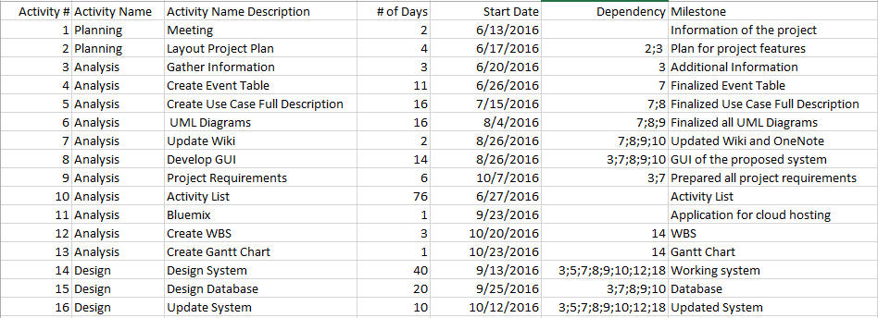

**6. Deliverables**

Deliverables specified for the project include:

1. An acceptable Quality Plan
2. An acceptable Change Management Plan
3. An acceptable Software Requirement Specification
4. An acceptable Scope of Work
5. An acceptable Project Vision and Scope
6. Progress Reports
7. User Manual
8. Final Paper

**7. Review of Quality Plan**

This quality plan will be reviewed every consortium or consultancy meetings, whether the meeting is with the project sponsor or project adviser, to achieve consistency of the project with the documented objectives and deliverables. This document will also be reviewed together with some improvements of the system.

**8. Document and Record Control**

Project documents, records and data will be managed and stored in Projects Wiki (www.Projects2.apc.edu.ph/wiki) by Buan, Michael John S., Caranto, Edric Jon Cleon B. and Carlos, Christian Aleck S. and GitHub (www.Github.com), a web-based repository hosting service that propose all the distributed version control. It can accessible for consultation by all the members of the team.

The Project Vision and Scope, Scope of Work, Software Requirement Specification, Change Management Plan and Quality Plan will be issued to the project stakeholders.

*The Quality Plan and Data Management Plan will be issued to all members of the consortium.*

Project Progress Report will be issued to the following:

* Professor
* Project Adviser

**9. Documented Procedures**

*Give the references of any in-house and/or published methods or procedures used during the project. References need not include the issue/version number, providing that staff are informed separately of modifications to Procedures. Otherwise, provide a basic resume of methodology with an indication of how it will be archived for future reference. Any centrally administered documents that relate to quality assurance should also be referenced.*

**10. Additional Information**

Unless included in associated technical procedures, any other information that has direct relevance to the quality of the product or service being provided should be included in the Quality Plan. This could include:

1. additional procedures and controls for the review and verification of deliverables or other documents;
2. special requirements for the identification and traceability of products, including, where applicable, the traceability of staff performing specific duties;
3. special criteria for identifying the status of inspection and test implementation of procedures;
4. minimum qualifications, training or experience required of staff to undertake certain activities, or any specialist staff training;
5. process control requirements, including monitoring of activities, and user access control;
6. requirement for servicing of a product for which ongoing maintenance is required;
7. specialist statistical techniques required.

Prepared by: Date:

Buan, Michael John S.

Checked by: Date:

Caranto, Edric Jon Cleon B.

Approved by: Date:

Carlos, Christian Aleck S.